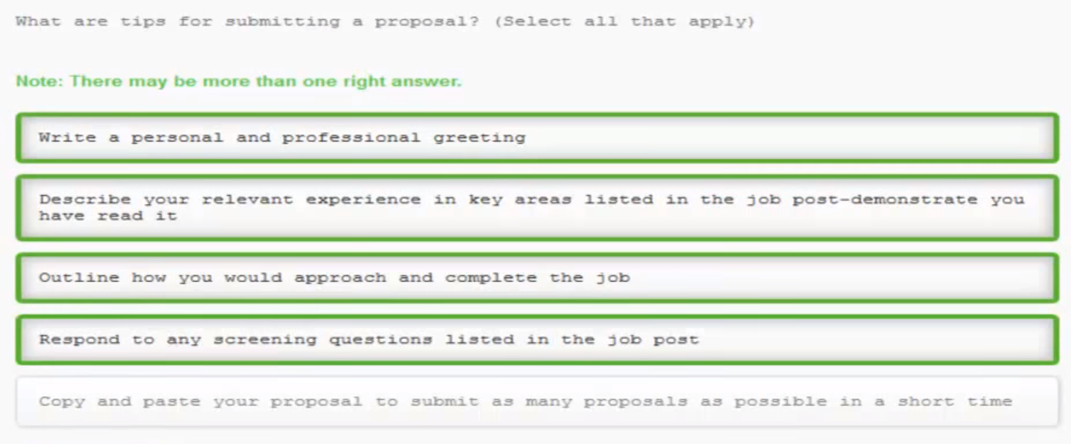

What are tips for submitting a proposal? (Select all that apply)

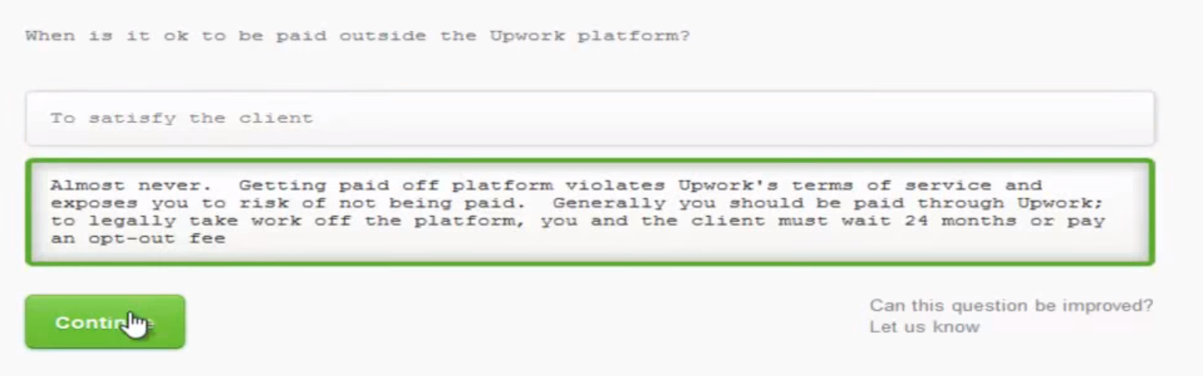

When is it ok to be paid outside the Upwork platforms?

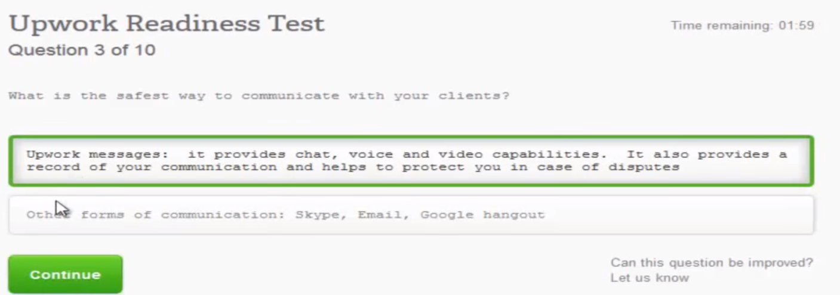

What is the safest way to communicate with your clients?

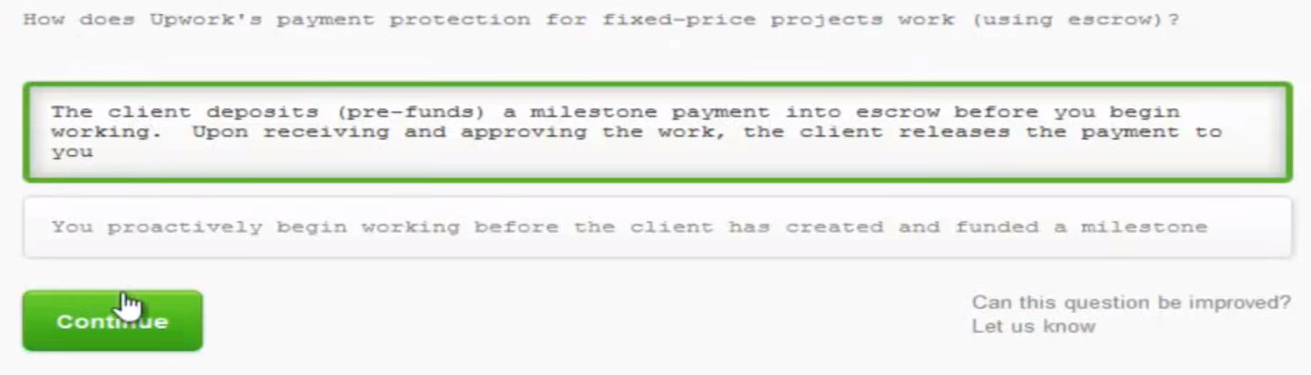

How does Upwork’s payment protection for fixed-price projects work (using escrow)?

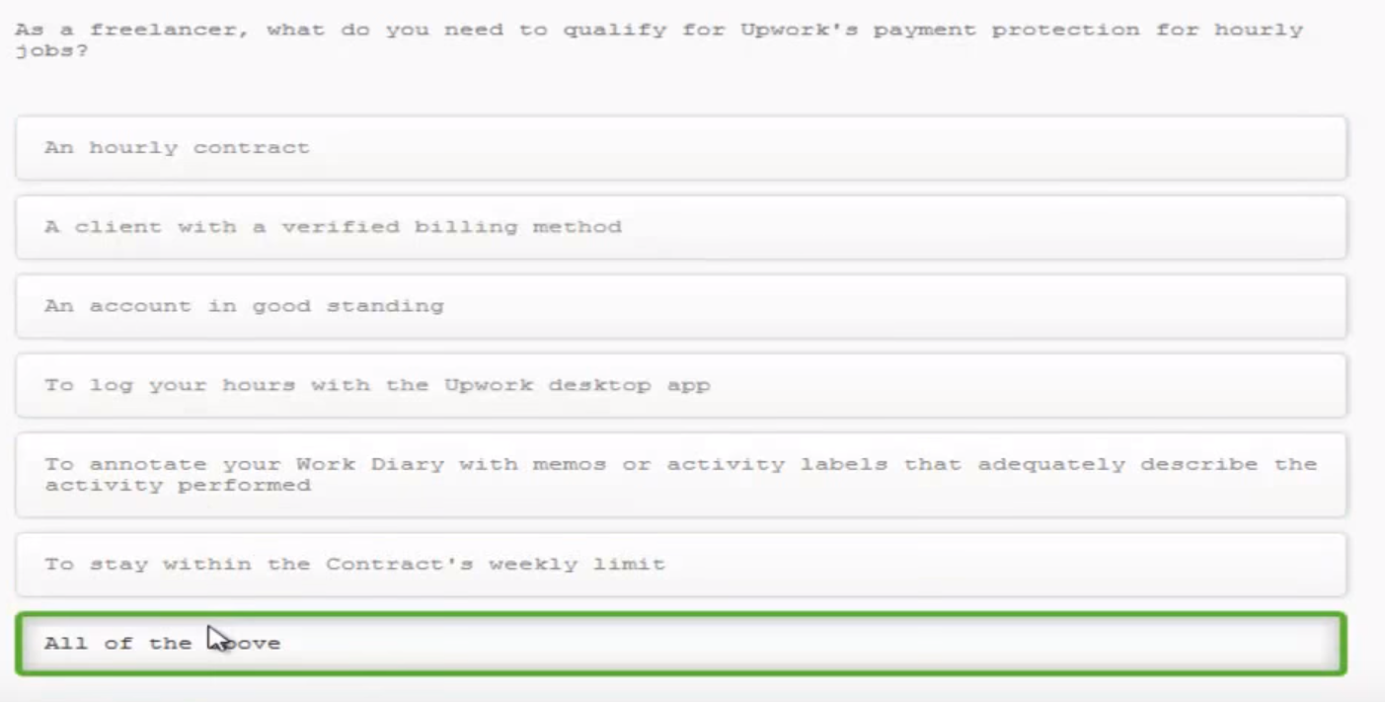

As a freelancer, what do you need to qualify for Upwork’s payment protecton for hourly jobs?

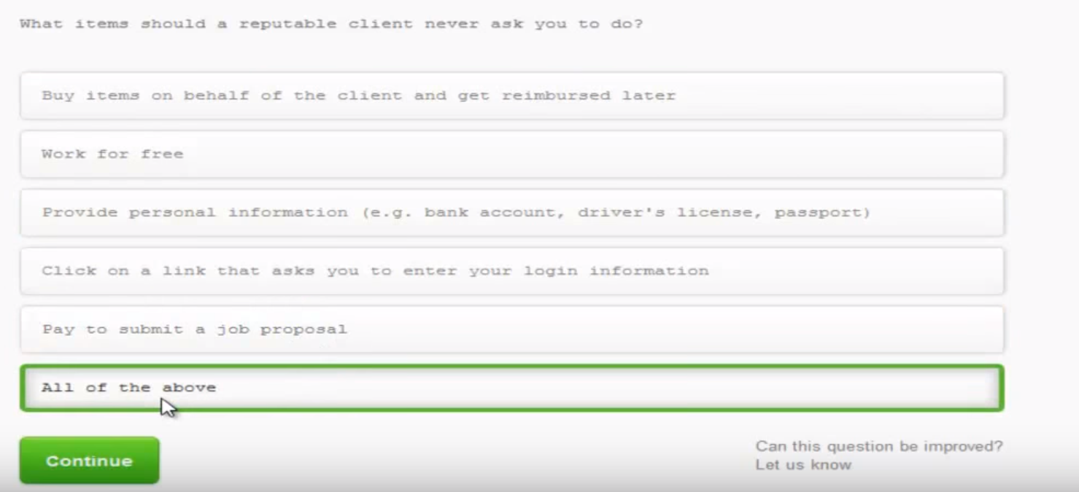

What items should a reputable client never ask you to do?

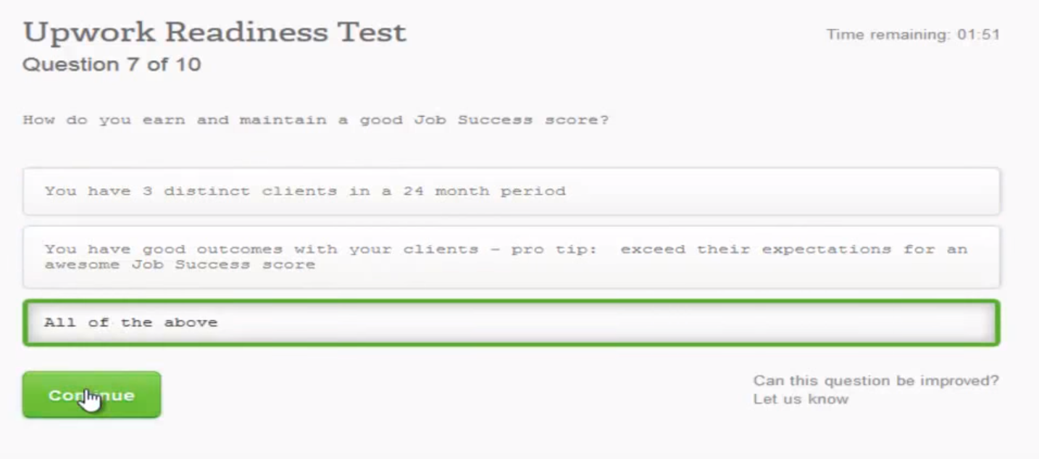

How do you earn and maintain a good Job Success score?

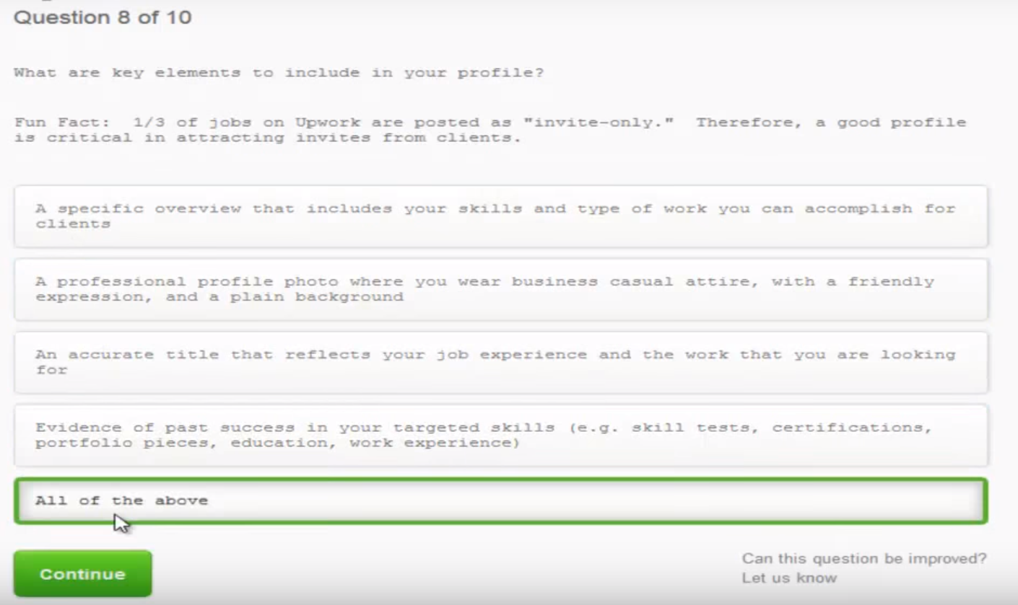

What are key elements to include in your profile?

Fun Fact: 1/3 of jobs on Upwork are posted as “invite-only.” Therefore, a good profile is critical in attracting invites from clients.

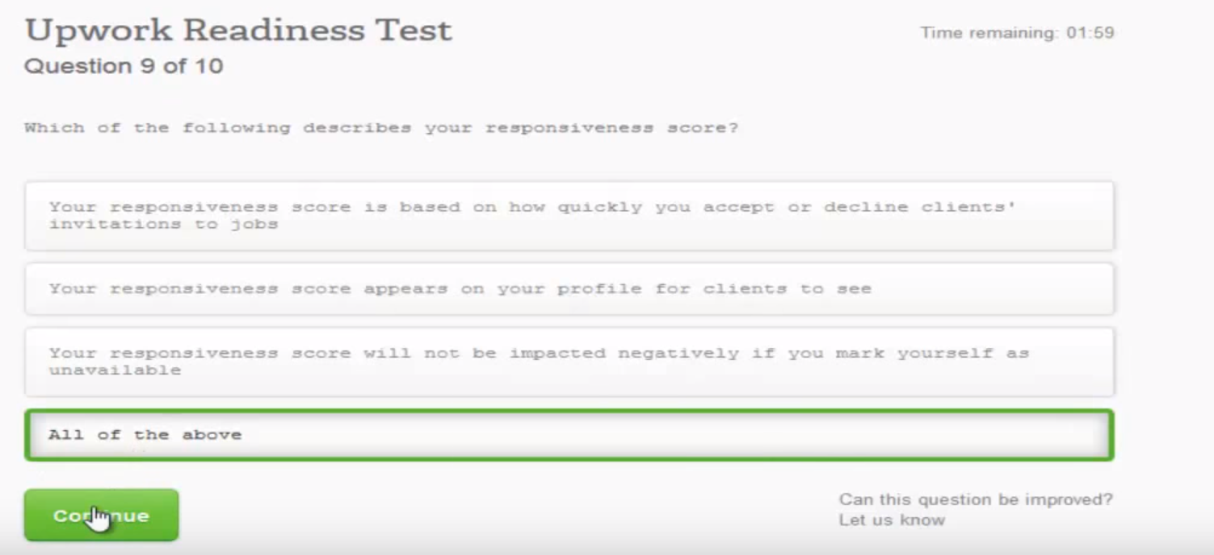

Which of the following describes your responsiveness score?

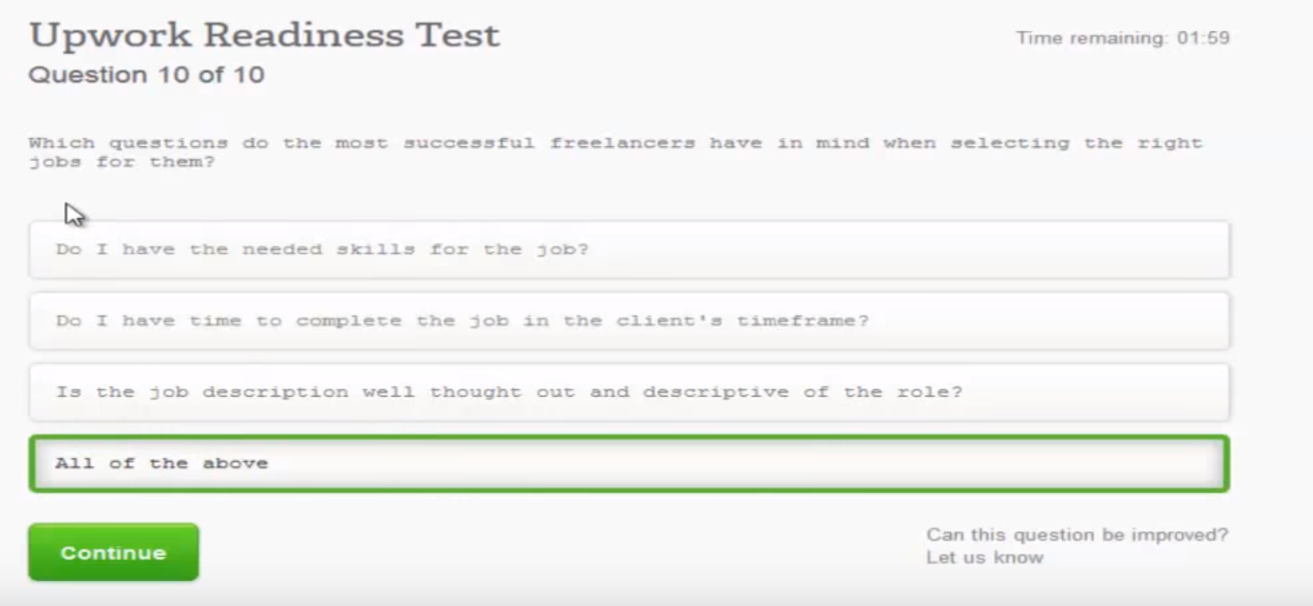

Which question do the most successful freelancers have in mind when selecting the right jobs for them?